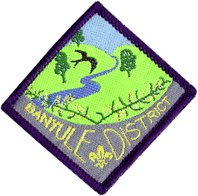
Banyule District Cubs
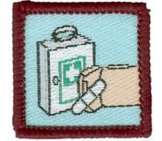
First Aid Course

Saturday 15 May & Sunday 16 May
1st Ivanhoe Scout Hall
49 Hawker St Ivanhoe

Cost: $25 per Cub (includes 2 lunches and 1 dinner)
Eligibility: Cubs who haven’t done the course and are due to go up to Scouts
by end of June 2022.
Wear: Full uniform
Saturday: Arrive well before 11-00am (need to have time to sign in).
Finish: 7-30pm.
Sunday: Arrive well before 9-30am. Finished by 2pm
Cubs need to be signed in and parents to leave a contact number, both days.

All Cubs MUST bring a small personal First Aid kit on the Sunday morning (should be put together by the Cub). See your Akela for details about this. It should be fitted in a small container.

The Saturday will consist of training in a wide range of aspects of First Aid, along with breaks for some fun. There is one more training session on Sunday (First Aid kits) before we get into the testing session. In addition to a written multiple choice test, Cubs will be paired up and tested across a number of different scenarios where they will treat the ‘victim’ for the problems they find.

If your child needs to be absent for a small part of the weekend, could you please write on the form the time they will be missing.

We also need to know about any special dietary requirements.
- Please advise your Leader ASAP by email, to help with catering.

Return to your Akela by, at the latest, Wednesday 12th May
Banyule District Cub First Aid Weekend:

Cub Name.............................................. Pack.....................................
Dietary requirements..........................................................................
Will be missing from the Course? (When?).......................................................
Enclosed $25
Signed..................................... Phone No...................................

